OOPS Assignment

1)Write a singleton class. Confirm that singleton class cannot be inherited.

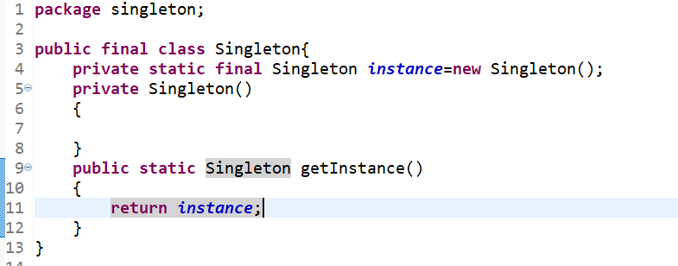

2)Test the following principles of an abstract class.

\*If any class has any of its method abstract then you must declare entire class abstract.

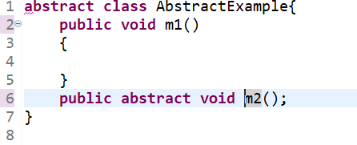

\*Abstract class cannot be instantiated.

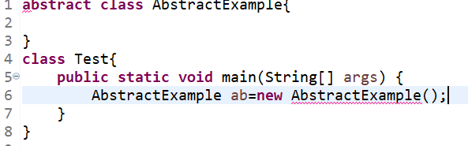

\*When we extend an abstract class, we must either override all the abstract methods in sub class or declare subclass as abstract.

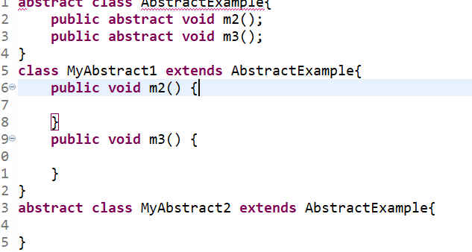

\*Abstract class cannot be private.

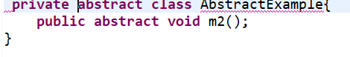

\*Abstract class cannot be final.

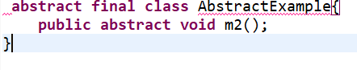

\*You can declare a class abstract without having any abstract method.

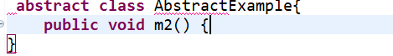

3)Write a program that has three classes Employee, Manager and labour where Manager & labour are the two subclasses of employee. use polymorphism method overriding.

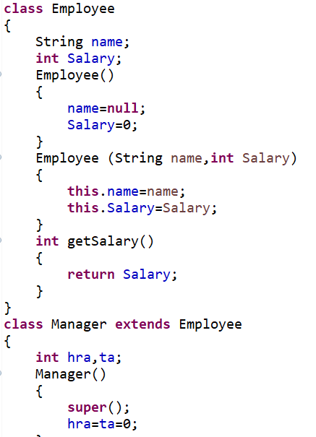

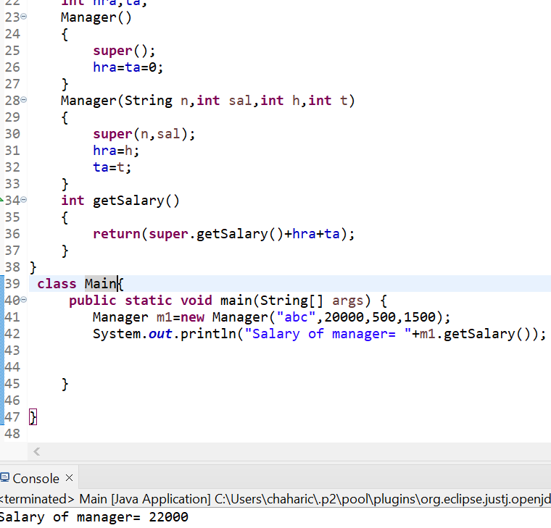

4)Write a program to consider saving & current account in the bank. Savings account holder has fixed deposits whereas current account holder has cash credit. apply polymorphism to find our total cash in the bank.

